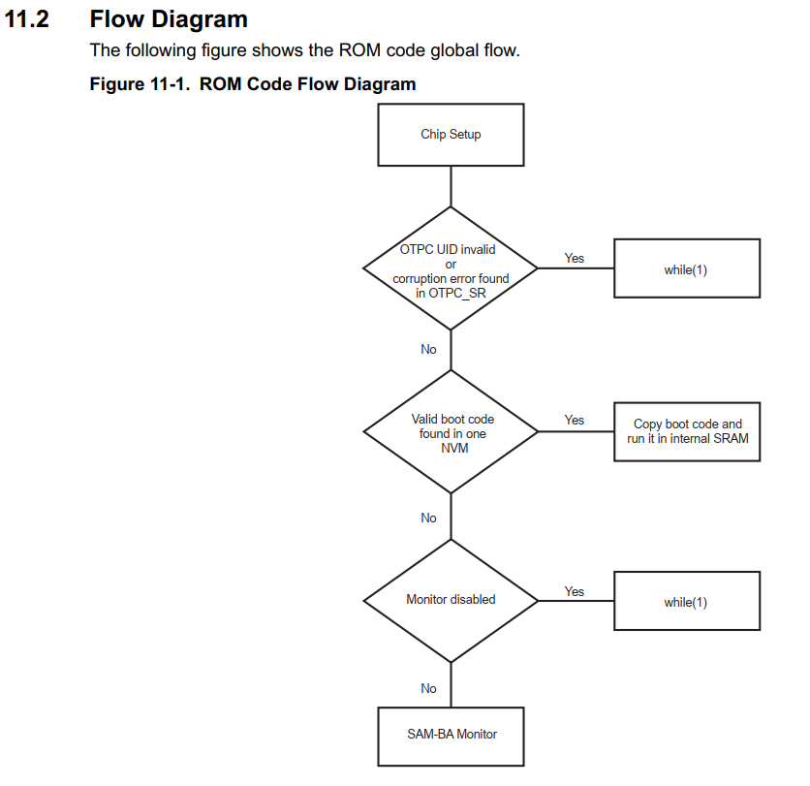

1, Chip Setup

2, Boot Configuration Controller (Store in OTP area), Default sequence:

SDMMC0 IOSET0

SDMMC1 IOSET0

QSPI0 IOSET0

SPI0 IOSET0

NAND0 IOSET0

